Online Education Course Design

This guide was created to assist faculty members in the School of Public Health and Health Professions (SPHHP) with planning and executing the design of a hybrid and/or online course. It is the result of discussions with many SPHHP faculty who have already survived the process of designing online courses. It is assumed that the reader is familiar with basic principles of course design and has previous experience in teaching a college-level course. This is not meant to be an all-inclusive “masterclass,” but rather, a starting point with basic, helpful information. Online delivery of SPHHP courses is an essential component of a comprehensive, 21st-century educational program. We recognize that, and are here to help. By the time you finish reviewing this guide, you will be well on your way for designing your new course, you will understand the tools available to all SPHHP faculty and be able to evaluate how best to use these tools. Most importantly, you will also know where to turn when you have questions.

Table of Contents
Getting Started 2
UB Supported Software 3
Moving a Seated Course to an Online Format 3
Weekly Activities 4
Week to Week Consistency 4
Learning Management Software – UBlearns aka Blackboard 4
The Course Menu 5
Home Page 5
Syllabus & Instructions 6
Formatting Weekly Activities 7
The Weekly Folder 7
Additional Content 7
Year over Year (Date Management) 8
Available resources for UBlearns 9
Course Components 9
Lecture Video Length 9
Recording Video Lectures 9
Video Lecture Analytics 10
Readings 10
Additional Videos or Podcasts 11
Assignments & Activities 11
Document Accessibility 14
Rationale 14
Quickest/Easiest Steps to Make a Document More Accessible 14
More Information 16

Getting Started
As you proceed through this workbook, keep in mind the following questions:

- How will you organize your course: by units, by chapters, by weeks?
- How will you transform your (assumed) lengthy in-person lessons into meaningful digital “chunks” from which students can learn?
Thoughts for New Hybrid/Online Course
Organization of new course
New component ideas
Engaging the online audience
Assessing online audience
- How will you assess your students, e.g. when it comes to participation, which is traditionally measured face-to-face?
- How will you engage your students using multiple delivery modes?
Answering these questions will help you determine which tools will be best for your course. Use the space below to jot down some initial thoughts answering the questions above. Then use the information and tools described in this workbook to formalize what ideas you will use.
In-person/Previous Courses
Organization of course
Typical lesson components
Engagement with live students
Assessments with live students

UB Supported Software
The following software options are available to all faculty members to use in support of teaching seated, hybrid and/or online courses. These will be referenced throughout our guide.
- UBlearns (Blackboard): centrally supported learning management system used to create, deliver and manage course content as well as monitor participation and assess performance of students
- Panopto: used to record, edit and publish video and audio content; can connect directly to UBlearns course, and can have students submit video content as well
- Webex: web conferencing tool used for live interactive video and audio connections; can be used for live broadcasting of class, virtual office hours, and can also record content

Moving a Seated Course to an Online Format
With traditional, seated courses, students typically review preparation materials, including readings, videos, audio content, etc., and then come to class and listen to lecture and take part in in-class activities. All of these learning activities can still be part of an online format, however, rather than thinking of the ‘before’ class material and ‘during’ class material, consider all the material together. You will not want to simply record a 90-minute live class and post it for the online class; that would not be engaging for the online students. Instead, there might be a 10-15 minute lecture video introducing the material for the week, then an assigned reading, followed by a lecture about that reading, etc. These materials can be structured into a Roadmap, as discussed further in this guide. This allows preparation material to be integrated with lecture material, providing students the opportunity to work through all of a given week’s material and gain mastery of the content.

Lectures for online courses are typically recorded sessions with the professor talking through his or her slides, just as in an in-person lecture. However, one major difference is when preparing lecture materials for online courses, lecture videos should be divided into thematic sections that typically last no more than 20 minutes. This is advantageous for a few reasons, including making it easier to update lectures in the future (rather than re-record a full 90 minute lecture, you could simply record the 10 or 20 minute segment), as well as keeping students engaged with the material.

Weekly Activities
As you develop your course, it’s helpful to think about how material is distributed week over week. Often, it’s helpful for students to see the topic area for the week; it helps build a sense of content, week over week, as shown in the example. Note that for some courses, it may be beneficial to have over-arching modules for courses. Each module may include a few weeks of content and could be linked thematically or could be material that falls between natural breaking points in a course (e.g., exams). If you choose to present your material in modules, you should also include a video orientation to each module. The module orientation should include at least a short introduction to the module topic, and indicate what materials need to be reviewed, and what activities and assignments need to be completed.

Within each week’s folder, there should be a consistent layout of information from week to week. The first item should be a Weekly Roadmap, formatted as a numbered list. This should give a quick overview of the week (see example below), as well as the due date(s) for items. Note that in this example, all items are due by Sunday, 11:59pm (see note on consistency below). The weekly roadmap should indicate what students need to do, in the order they should do it. It’s also helpful to list times for videos, and even page numbers for readings. The roadmap should also dictate the order of all items to follow, additional examples follow.

Each week should be a mixture of active and passive learning techniques. Generally, this will take the form of video lectures and readings (more passive approaches), and activities (more active approaches), such as discussion board posts, Wikis, and journal reflections. Additional sections of this document review the different activity types.

Week to Week Consistency
Your weekly materials should be as consistent as possible; this means materials show up at the same time each week (e.g., Mondays at 9am) and then are due at the same time each week (e.g., Sundays at 11:59pm). f you need to deviate from this pattern, make sure you notify students explicitly and well in advance. Further, each week should have a roadmap. This does not mean the activities themselves must be the same – you can (even should!) vary activities between forums, wikis, blogs, etc.

Learning Management Software – UBlearns aka Blackboard
UBlearns, powered by Blackboard, is the official learning management software for the University at Buffalo and SUNY system. One of the first decisions you will want to make is regarding how you will organize your course. Will you divide it by weeks, divide it into units and/or chapters, or perhaps another model?

It is highly recommended that online courses have a similar look and feel. This allows the course to be conisitent with with other online courses and students have a similar UBLearns format, across all UBLearns courses. Here’s how to create a consistent UBLearns set-up.

The Course Menu
There are specific instructions for altering the course menu available, including renaming individual links. We recommend the following layout for course menus for all online courses:
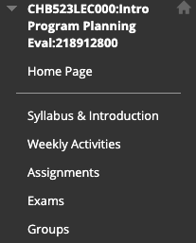
- Homepage – This is where announcements post, as well as additional items (discussed in a further section)
- Syllabus & Introduction – This section contains key course information, including a syllabus overview video and introduction to the professor/course video
- Weekly Activities – this is where students go for the main items each week. Within this link are a series of weekly folders, numbered and set to automatically appear at the start of the week
- Assignments – this section hosts assignment information. These assignments are not specific to a given week; for example, weekly discussion board posts are NOT included here. This is for over-arching assignments for the course.
- Exams – if your class uses exams, having a specific tab that outlines information on the exam, as well as is the location the exam is posted when available
- Additional critical content – in the example, you’ll see that “Groups” is an additional tab. We wanted to give students quick access to their groups, as well as the forums in which they can participate with their groups. You could add specific information like that here, at the bottom of the course menu.

All additional UBLearns tabs should be removed or hidden (for instructions, see link above).

Home Page
The homepage should be customized for your course. At minimum, it should include the “My Announcements” section, which is typically one of the default options. The other default options are generally unrecommended, unless you actively use those functions. For example, “What’s New,” “Alerts,” and “Needs Attention” should generally be hidden. You can accomplish this by clicking on the “X” in the upper right corner of the box.

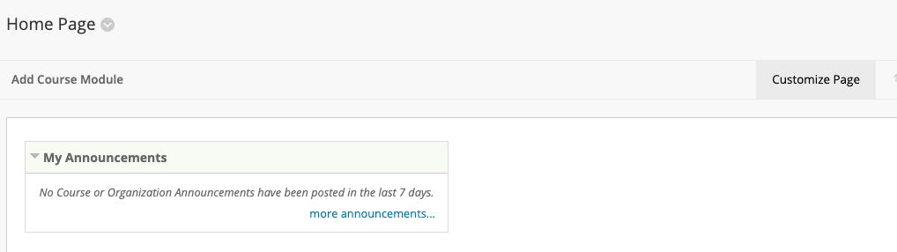
Also note that in the homepage screen you can change the color scheme using the “Customize Page” function; clicking on that button will provide around a dozen color options. You can also “Add Course Module” which provides functions like calculators and dictionaries. Select these carefully, as the more ‘busy’ the page, the more difficult it will be for students to navigate it.

Syllabus & Instructions
This link should include the course syllabus, using the template for online classes. There should also be a brief (5-10 minutes) video introducing students to you, the course, and the syllabus. This video should include…
- Who you are (research interests, other courses you teach, something interesting, etc)
- Overall objectives of the course
- Best way to contact you with questions, as well as when/how office hours will be held
- Overview of course structure, including major assignments, tests, etc., as well as how those assignments/tests will be administered

This section can also include a link for the syllabus, as well as any other critical content you’d like to highlight. This may include a statement about communication and expectations, like the one here.

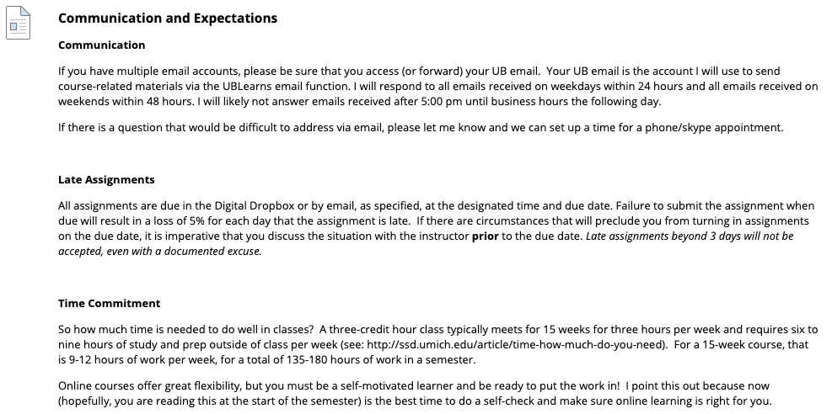

Formatting Weekly Activities
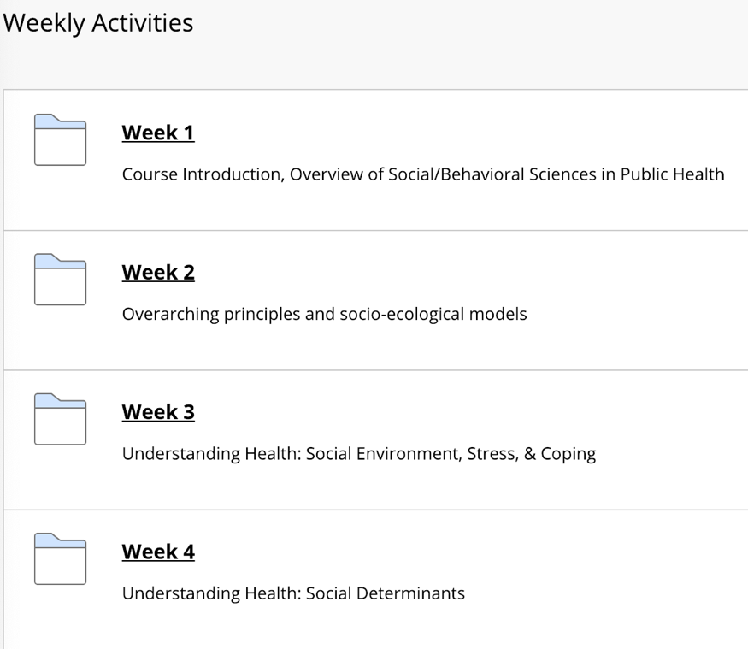
This should be an outline of weekly material, divided by week, or as modules that include several weeks worth of material. These should be set to appear to students on the set day/time, and then remain throughout the course. Often, it’s helpful for students to see the topic area for the week; it helps build a sense of content, week over week.

The Weekly Folder
Within each week’s folder, there should be a consistent layout of information from week to week. The first item should be a Weekly Roadmap, formatted as a numbered list. This should give a quick overview of the week (see example below), as well as the due date(s) for items. Note that in this example, all items are due by Sunday, 11:59pm (see note on consistency below). The weekly roadmap should indicate what students need to do, in the order they should do it. It’s also helpful to list times for videos, and even page numbers for readings.

The roadmap should also dictate the order of all items to follow. For example, scrolling down on the example page would reveal lecture segment 1, followed by lecture segment 2, and so on.

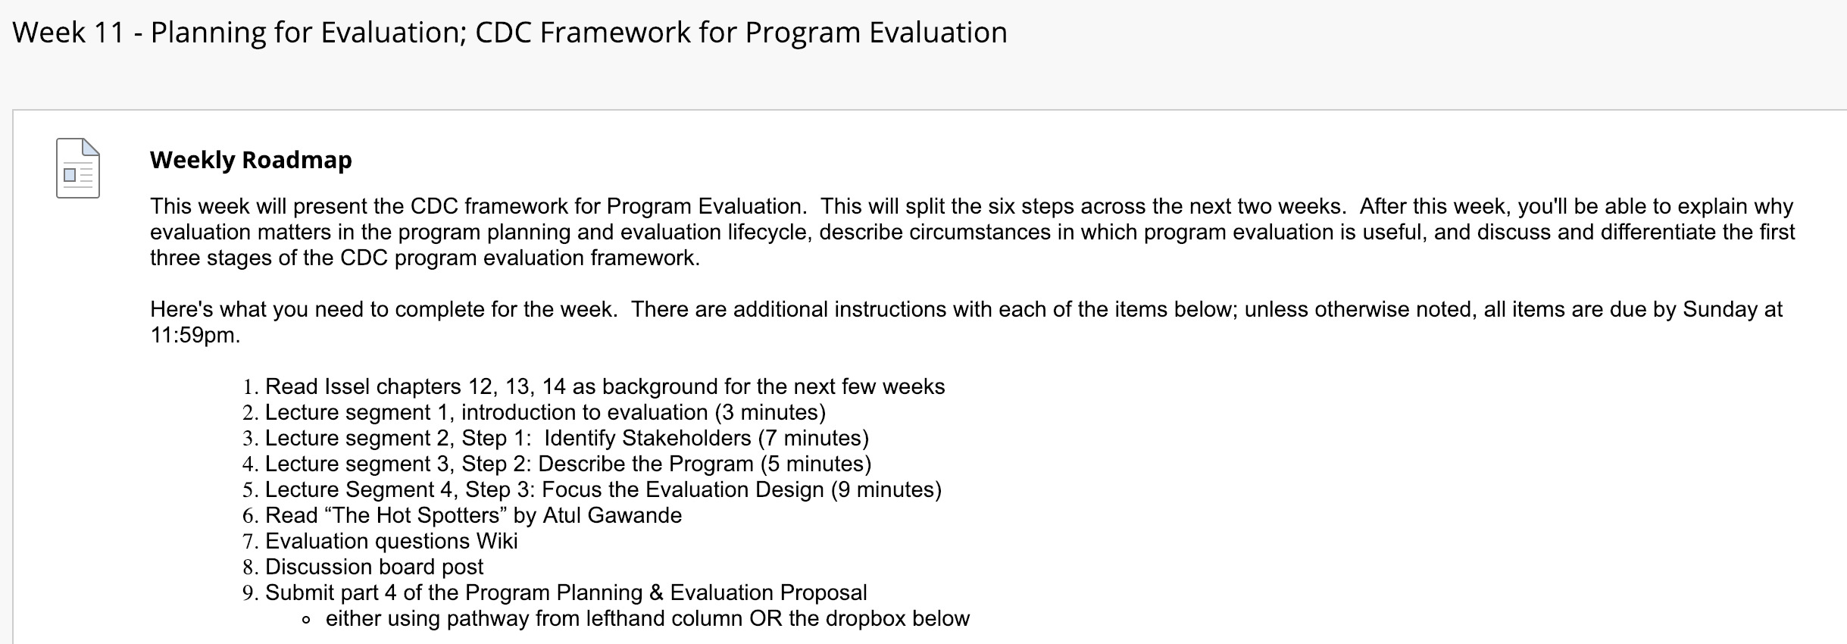

Additional Content
Whenever possible, add course content as an “item” rather than as a document to download. For example, the exam content section here shows information on the exam, rather than requiring the students download and open a document.

Of course, pdfs for readings/journal articles should maintain their original form. This applies specifically to material about the course, like assignment instructions, exam instructions, course overviews, etc.

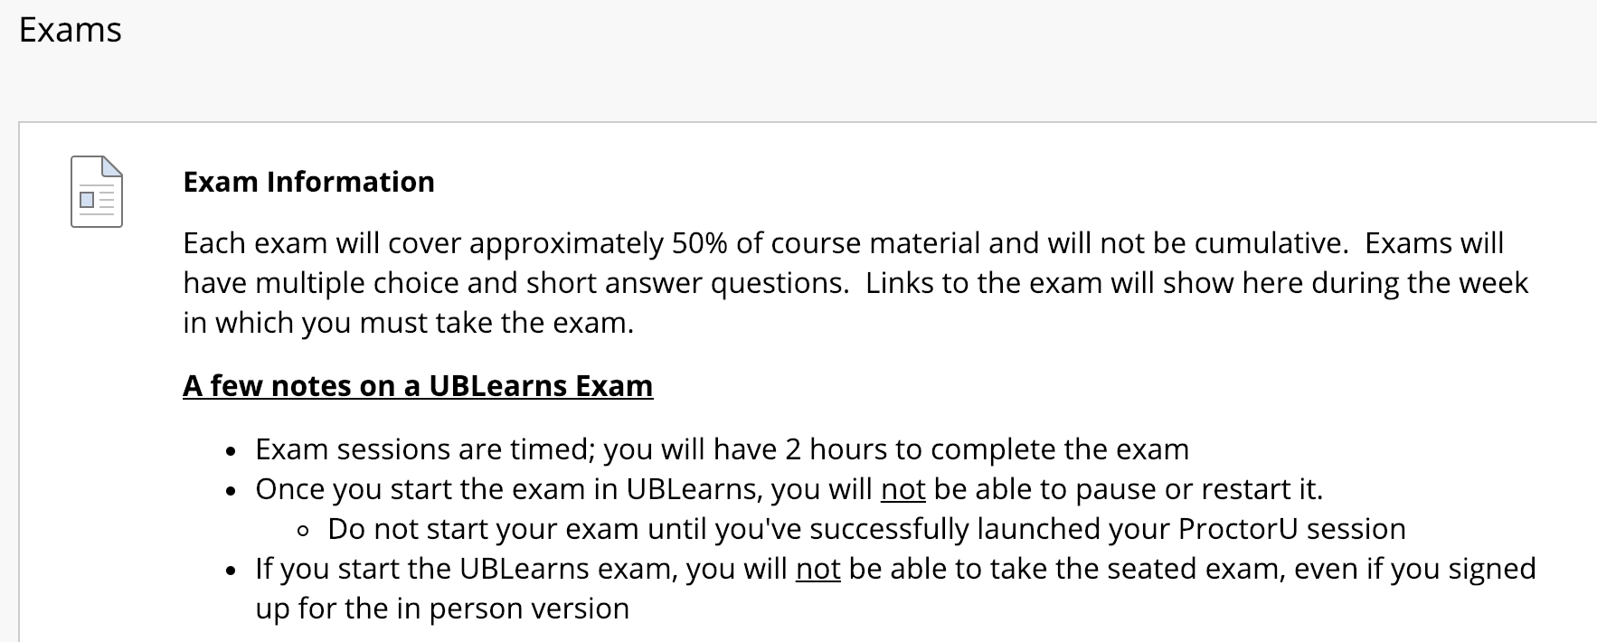
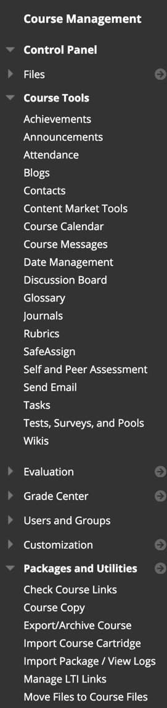

Year over Year (Date Management)
Once you’ve created your content, you can use the UBLearns content and structure year-over-year. These features are available in the Course Management toolbar, on the left-hand side of UBLearns. You may need to click on the triangle to expand the options (as shown on the right of this page).

The first step for this process is to export your course and save it. Under the ‘Packages and Utilities’ section, select export/archive course and follow the prompts after clicking ‘Export Package.’ Note that this may take some time, so you will receive an email when the process is complete. At this point, you can then download the ZIP file via UBLearns.

Once your new course is up and running in UBLearns, you can import this file. Note that you should not unzip the export file prior to the import; UBLearns will want the file as it was originally downloaded. You will be able to select what course components you import, including whether materials from the previous version (assignments, forum posts, etc) are included. We recommend not importing previous students’ content – you’ll need to go in and delete it for the new students in the course!

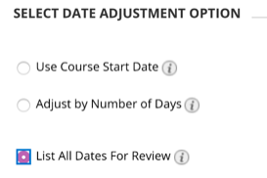
There are a few different ways to use the Date Management tool, either adjusting the course start date or adjusting by the number of days. We recommend adjusting dates as needed and then going back into the Date Management tool and ‘Listing all Dates for Review.’ This will give you a list of all dates (including start and end times when specified) for all components in your course, allowing you to check and make sure dates were adjusted correctly.

Available resources for UBlearns
- UBlearns for Faculty
  - Connecting Panopto and UBlearns

Contact Information for UBLearns Support
Phone support: 716-645-6188
Email support: ublearns@buffalo.edu
Walk-up support: 05 Norton Hall
You can also submit a help request on their website
Note that Support Hours are Monday - Friday 8:30 a.m. - 4:30 p.m

Blackboard Support
There is also a robust website with getting started guides, support articles, how-to videos, and more from Blackboard. Their main website is https://help.blackboard.com/Learn/Instructor.

Course Components
Each week should be a mixture of active and passive learning techniques. Generally, this will take the form of video lectures and readings (more passive approaches), and activities (more active approaches), such as discussion board posts, Wikis, and journal reflections. Additional sections of this document review the different activity types.

Lecture Video Length
Some education experts state that very short videos (5 minutes) are the most effective for student engagement. However, this can be challenging in graduate level coursework, which often works with complex topics and nuance. Therefore, it’s recommended videos have a maximum length of ~15 minutes, and several videos are used for a given week’s material. For example, in the Week 11 example above, you’ll see three lecture segments covering the first three steps of the CDC framework for evaluation. It’s also helpful for students to indicate the video length in the weekly roadmap.

Note that shorter videos are also helpful for you as an instructor! If you want to update a lecture segment with a new article or revise the way you presented material, it’s much easier to re-record a short clip than spend an hour or more re-recording an entire lecture.

Recording Video Lectures
Panopto is UB software for recording video lectures that work with both Microsoft Powerpoint and Apple Keynote. There are a number of resources available for faculty to learn how to use and edit Panopto videos. You are also able to add captions to Panopto recorded videos to improve accessibility of lecture segments.

When posting video segments to UBLearns, UBIT recommends you add the video as an “Item” from the “Build Content” Menu. Once you open “create an item,” as shown in the screenshot below, use the “Mashup” option to add your Panopto video.

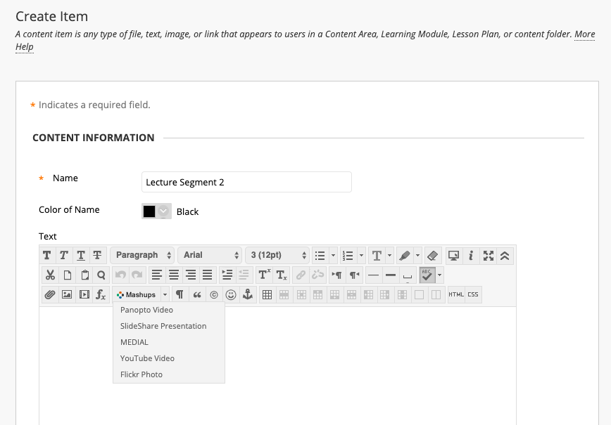
Video Lecture Analytics
Panopto is also useful because you can check usage for any video segment you create in their online portal. There are a few ways to do this, including spreadsheet style reports, and you can view this information on a video-by-video basis, or for the class overall.

For a video-by-video basis, navigate to the video of interest and click “Stats” (second from the right).
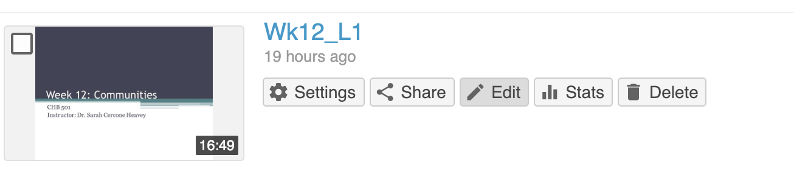

For overall analytics, at the top by your name is a little graph icon. Clicking on this will return an overall view, as well as the ability to click on individual lectures and obtain a student by student indicator for video completion.

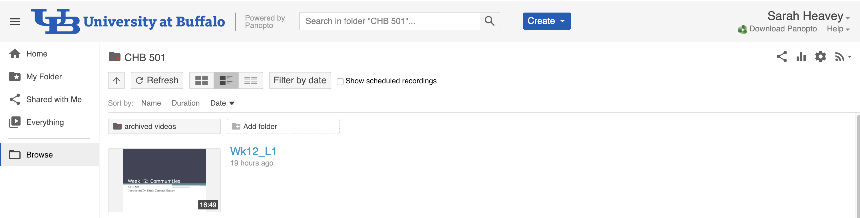

Readings
Instructors often post readings for students to complete as “homework” in a seated class. With an online class, think of the reading as part of the weekly activities for students to master the material. When posting readings, it is recommended that instructors includes additional context, as well as guiding questions for the reading (see example). The overview and reading guide helps the student get more out of the reading and is often the same content you would use to discuss the reading in an in-person class.

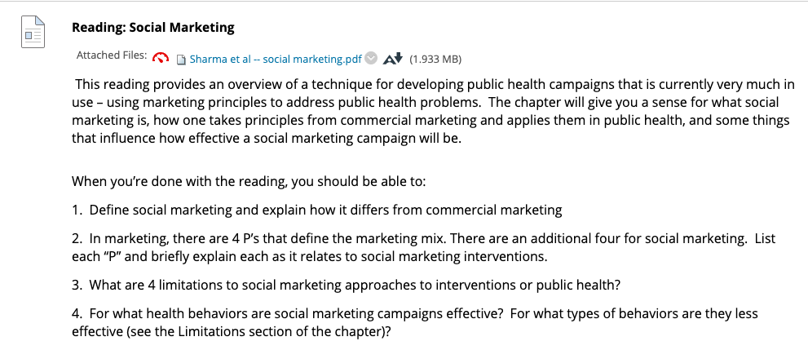

Additional Videos or Podcasts
Whenever possible, additional videos (like TED Talks) or podcasts should be embedded as content within the week’s material (see example). A quick introduction is also helpful for these sorts of materials, and students generally respond well to more “contemporary” resources.

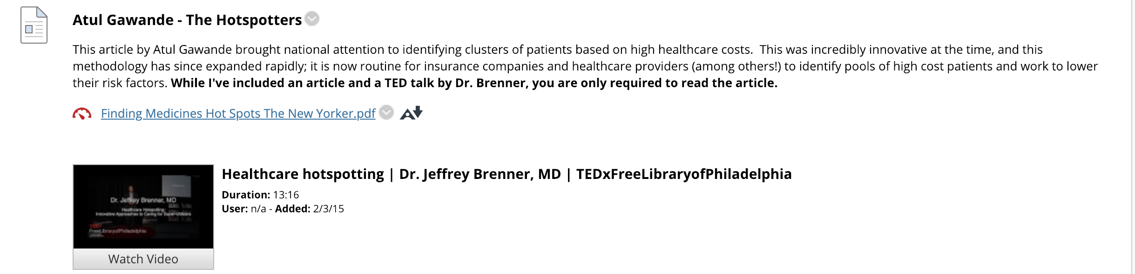

Assignments & Activities
UBlearns provides a variety of assignments and activities that can be used to have students interact with the Instructor and/or their classmates. Some of the most frequently used items are explained here.

Basic Assignment Information
You can create an Assignment where students can enter text or submit a file such as a Word document, slide deck or PDF. When you create an assignment, a column in the Grade Center is automatically created. Instructors have the option to assign a Due Date, check submissions for plagiarism using SafeAssign, allow multiple submissions, as well as other options.

Discussion Boards
The purpose of the discussion board participation is to get students writing in order to express what they have learned, to clarify what they think, and to broaden awareness. At the same time, students are also provided a chance to “virtually” connect with others in the course. Example text for defining appropriate discussion board participation is included in the example syllabus.

Finally, here are a few suggestions for activities that extend beyond a traditional discussion board format, provided by OSCQR. For additional suggestions, please visit the OSCQR Standard 31 page.
- Create scenario-based discussion forums for learners to interact in. Establish and assign roles for learners within those scenarios.
- Use mini-cases as pre-lab work where learners can see what might go wrong before they are actually immersed in an online lab.
- Have learners create and facilitate course related scenarios.
- Have learners turn in reflective essays along with applied learning activities to measure critical thinking and reflection stages of the process.
- Assign “offline” activities to learners, and have the learners “debrief” in the online environment.
- Require foreign language learners to interact with native speakers (online) and summarize their experiences.
- Have learners document their real-world experiences through digital storytelling tools

Blogs
The Blog feature of UBlearns is another way that students can share knowledge and discuss materials. Students and Instructors can include text, images, links and videos to their posts and can comment on each other’s posts. An important difference between discussion boards and blogs is that when using a blog, one can easily scroll through all of the posts that have been uploaded, whereas in the discussion board, you need to click into each thread in order to read it. With a blog, however, there is no feature to allow “post-first” restrictions. Students can see all of the posts even before they have submitted their own.

Other formats

Journals
Journals provide a personal space for students to communicate privately with the Instructor. These are ideal for individual projects that other students do not need to review.

Wikis
Wikis provide a space where students can build content together. All students can create pages and enter comments. Wikis can be used for group or full-class assignments, promoting collaboration.

Quizzes, Tests, & Exams
There are a number of ways to give quizzes, tests, and exams in an online class. If you want to give a test/exam and ensure students are not able to source their answers from course materials, UBLearns now has Monitor, a function that records students while they take an assessment and provides ‘flags’ for suspicious behavior using AI software. This is a UBLearns supported tool, so you can contact their help line for assistance. In addition, there is a resource page and quick start guide. Perhaps most importantly for students, there is no additional cost for this option. Note that this is not a live proctor; instructors looking for a live proctor will need to use other tools.

For some courses, ‘open book’ tests/exams can work well, particularly if students are required to synthesize their knowledge and provide descriptive responses. In these situations, the test can be given without restrictions on what materials students may have access to. This would mean students would not need to use proctoring software.

To ensure students are not able to look up every single answer, you could balance the number of questions with a relatively modest timeframe to complete the exam. The nature of the exam questions (multiple choice, short answer, longer essay, etc.) will help determine an appropriate length of time. Further, previously given exams might help inform this for courses previously taught as seated classes.

UBLearns has several functions that facilitate this for instructors, including…
- time limit per question (e.g., each question must be answered in 2 minutes, and the test moves forward automatically)
- time limit for the exam (e.g., the exam must be completed within 60 minutes of launching the exam)
- number of times the exam can be opened (e.g., the student can only launch the exam once)
- whether the student can go back to previous questions in the exam
- ability to define a time window in which students must start the exam

Document Accessibility

Rationale
- 10% of UB students use some kind of assistive technology (e.g., screen readers, screen magnification, speech recognition, and/or hands free devices)
- Disabilities can be permanent, temporary (injury) or situational (in a noisy area)
- 1 in 12 men and 1 in 200 women are color blind
- Addressing accessibility often improves user experience for all
Source: Mark Greenfield, Web Accessibility Officer
Office of Equity, Diversity and Inclusion, UB

Quickest/Easiest Steps to Make a Document More Accessible
- Enter basic metadata:
  - Specify author, title, keywords
    - MS Office: File Info
    - Adobe Acrobat: File Properties
  - Set language as English:
    - MS Office: File Options Language
    - Adobe Acrobat: Edit Preferences Language Application Language
- Use accessible fonts
  - In general, Sans Serif fonts are easier to read
    - Arial, Calibri, Tahoma, Verdana
  - Some Serif fonts are ok, especially for printed documents:
    - Georgia, Times New Roman
  - Avoid harder-to-read fonts
    - Brush Script, Bradley Hand, Cooper Black, Curlz, Garamond, Monotype Corsiva
- Use appropriate color contrast – higher contrast is easier to read
Good
Good
Good
Good
Good

Bad
Bad
Bad
Bad
Bad
  - Consider how content will look in Grayscale. Consider using patterns when displaying data.
- Consider spacing
  - Suggested: Line height/spacing: 1.5 times the font size
    - Minimally: use 1.15 times the font size
  - Screen readers do not like paragraph marks; don’t use hard returns to add extra space, use the “Line Spacing” options and “Styles” instead
  - “Justified” text = not recommended
  - Lists using numbers or bullets allow for easier navigation/reading
    - If a table is being used, keep it simple and use headers for columns.
- Make sure all images have meaningful “alt text”, which is read by screen readers
  - Be succinct; phrases such as “image of…” are usually not necessary
  - MS Office: right click on image Format Picture Layout & Properties Alt Text add your description
    - It is recommended that text be entered into the “Description” field, as opposed to the “Title” field.
  - Adobe Acrobat: Accessibility tool Set Alternate Text
- Word doc to PDF
  - Best: Use Acrobat ribbon in Word
    - Check Preferences; these should be checked: Create Bookmarks, Add Links, and Enable Accessibility and Reflow with Tagged Adobe PDF
    - Click Create PDF
  - OK: File Save as PDF
  - Bad: “Print to PDF” (this creates on large image)
- Ally in UBlearns
  - Ally automatically checks course materials and provides an accessibility score for each file. (Scores are only visible to instructors.)
    - It offers step-by-step instructions to improve accessibility.
    - It also creates alternative, accessible file formats for students to download
  - Score ranges:
    - Low: File is not accessible and needs immediate attention.
    - Medium: File is somewhat accessible and could use improvement.
    - High: File is accessible but could be improved.
    - Perfect: File is accessible and no improvements are needed.

More Information
- 100-page detailed document from OFFICE OF EQUITY, DIVERSITY & INCLUSION, WEB ACCESSIBILITY
- How to check accessibility
  - MS Office: File Info Check for Issues Check Accessibility
  - Adobe Acrobat: Accessibility tool Full Check
- Helpful Websites/Sources for this document:
  - Accessibility support information at UB
  - UBlearns (Blackboard) Ally
  - WebAIM Document Accessibility Training

